SQL

Ray’s Rentals

Faran Azadi, Aamer Atique, Yusof Bandar, Naim Ahmed and Pritam Sangani

Table of Contents

1.0 Introduction 3

2.0 Amended ERD 4

3.0 Data Dictionary 5

3.1 Rental Record 5

3.2 Reservation Record 5

3.3 Dealer Record 5

3.4 Fault Report Record 6

3. 5 Customer Record 6

3.6 Enquiry Record 6

3. 7 Sold Bikes Record 6

3. 8 Bike Record 7

3. 9 Class/Size Record 7

3.10 Maintenance Record 7

3. 11 Bike Parts Record 7

3.12 Supplied Parts 8

3. 13 Parts Ordered 8

4.0 What We Learnt 9

4.1 Yusof Bandar 9

4.2 Naim Ahmed 9

4.3 Aamer Atique 9

4.2 Pritam Sangani 10

4.3 Faran Azadi 10

5.0 SQL Queries 11

5. 1 Parts and Maintenance 11

5. 2 Bike Models 11

5. 3 Bike Purchase Date 11

5. 4 Bike Maintenance 12

5. 5 Manufactures 12

5. 6 Bike Sales 12

5. 7 Enquiry Record 13

5. 8 Customer Record 13

6.0 Tables 14

6. 1 Enquiry Record 14

6. 2 Customer Record 14

6. 3 Sold Bike Record 14

6. 4 Dealer Record 15

6. 5 Reservation Record 15

6. 6 Bike Record 15

6. 7 Maintenance Record 16

6. 8 Fault Report Record 16

6.9 Manufacturer Record 16

6.10 Supplied Parts Record 16

6.11 Class Size Record 17

6.12 Bike Parts Record 17

6.13 Parts Ordered 17

6.14 Rental Record 17

# 1.0 Introduction

In this assignment, we were tasked with the jobs of first improving our entity relationship diagram (ERD) which we composed in our last assignment and then using it to create a data dictionary which consisted of tables containing information about what was in the diagrams tables. This was needed so it would be clear of which attribute was in the table were primary or foreign keys (also the location of which tables they were linked to) and what data type they were. From there we began to implement our databases using ORACLE. Each member of the group also had to create at least one SQL query or data entry to ensure we all took part. We documented our creation of the database and included screenshots as instructed.

# 2.0 Amended ERD

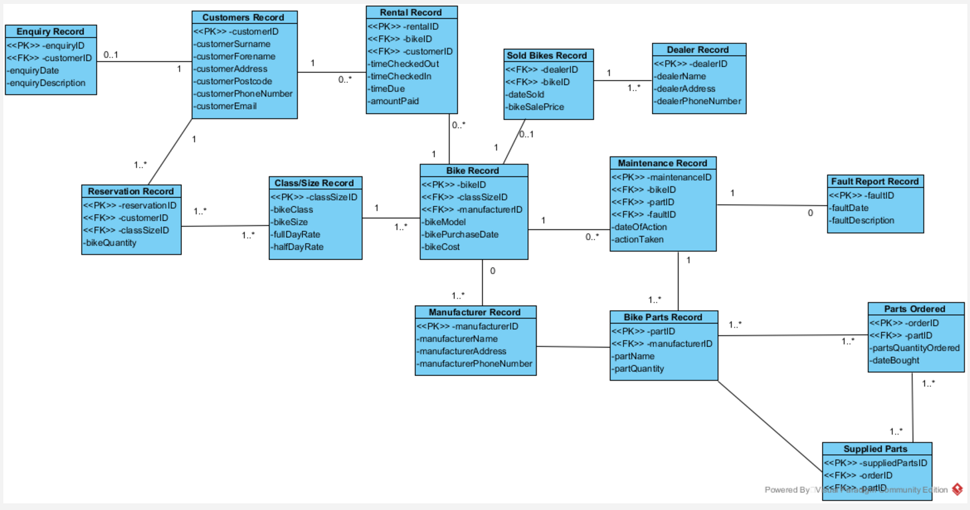

# 3.0 Data Dictionary

## 3.1 Rental Record

|  |  |  |  |  |  |  |
| --- | --- | --- | --- | --- | --- | --- |
| **Attribute Name** | **Key Type** | **FK Table** | **FK Column** | **Data Type** | **Length** | **Constraint** |
| rentalID | PK |  |  | NUMBER | 9 |  |
| rentalNumber |  |  |  | NUMBER | 9 | NOT NULL,  UNIQUE |
| bikeID | FK | BIKE RECORD | bikeID | NUMBER | 9 |  |
| customerID | FK | CUSTOMERS RECORD | customerID | NUMBER | 9 |  |
| timeCheckedOut |  |  |  | TIME | HH:MM:SS | NOT NULL |
| timeCheckedIn |  |  |  | TIME | HH:MM:SS |  |
| timeDue |  |  |  | TIME | HH:MM:SS | NOT NULL |
| amountPaid |  |  |  | DECIMAL | (5,2) |  |

## 3.2 Reservation Record

|  |  |  |  |  |  |  |
| --- | --- | --- | --- | --- | --- | --- |
| **Attribute Name** | **Key Type** | **FK Table** | **FK Column** | **Data Type** | **Length** | **Constraint** |
| reservationID | PK |  |  | NUMBER | 9 |  |
| customerID | FK | CUSTOMERS RECORD | customerID | NUMBER | 9 |  |
| sizeClassID | FK | CLASS/SIZE RECORD | sizeClassID | NUMBER | 9 |  |
| bikeQuantity |  |  |  | NUMBER | 3 |  |

## 3.3 Dealer Record

|  |  |  |  |  |  |  |
| --- | --- | --- | --- | --- | --- | --- |
| **Attribute Name** | **Key Type** | **FK Table** | **FK Column** | **Data Type** | **Length** | **Constraint** |
| dealerID | PK |  |  | NUMBER | 9 |  |
| dealerName |  |  |  | VARCHAR2 | 30 | NOT NULL |
| dealerAddress |  |  |  | VARCHAR2 | 45 |  |
| dealerPhoneNumber |  |  |  | NUMBER | 13 | NOT NULL, UNIQUE |

## 3.4 Fault Report Record

|  |  |  |  |  |  |  |
| --- | --- | --- | --- | --- | --- | --- |
| **Attribute Name** | **Key Type** | **FK Table** | **FK Column** | **Data Type** | **Length** | **Constraint** |
| faultID | PK |  |  | NUMBER | 9 |  |
| bikeID | FK | BIKE RECORD | bikeID | NUMBER | 9 |  |
| faultDate |  |  |  | DATE | DD/MM/YYYY |  |
| faultDescription |  |  |  | VARCHAR2 | 140 |  |

## 3. 5 Customer Record

|  |  |  |  |  |  |  |
| --- | --- | --- | --- | --- | --- | --- |
| **Attribute Name** | **Key Type** | **FK Table** | **FK Column** | **Data Type** | **Length** | **Constraint** |
| customerID | PK |  |  | NUMBER | 9 |  |
| customerSurname |  |  |  | VARCHAR2 | 30 | NOT NULL |
| customerForename |  |  |  | VARCHAR2 | 30 |  |
| customerAddress |  |  |  | VARCHAR2 | 45 |  |
| customerPostcode |  |  |  | VARCHAR2 | 8 | NOT NULL, UNIQUE |
| customerPhoneNo |  |  |  | NUMBER | 13 | NOT NULL, UNIQUE |
| customerEmail |  |  |  | VARCHAR2 | 45 | UNIQUE |

## 3.6 Enquiry Record

|  |  |  |  |  |  |  |
| --- | --- | --- | --- | --- | --- | --- |
| **Attribute Name** | **Key Type** | **FK Table** | **FK Column** | **Data Type** | **Length** | **Constraint** |
| enquiryID | PK |  |  | NUMBER | 9 |  |
| customerID | FK | Customers Record | customerID | NUMBER | 9 |  |
| enquiryDate |  |  |  | DATE | DD/MM/YYYY |  |
| enquiryDescription |  |  |  | VARCHAR2 | 140 |  |

## 3. 7 Sold Bikes Record

|  |  |  |  |  |  |  |
| --- | --- | --- | --- | --- | --- | --- |
| **Attribute Name** | **Key Type** | **FK Table** | **FK Column** | **Data Type** | **Length** | **Constraint** |
| soldBikeID | PK |  |  | NUMBER | 9 |  |
| dealerID | FK | Dealer Record | dealerID | NUMBER | 9 |  |
| bikeID | FK | Bike Record | bikeID | NUMBER | 9 |  |
| dateSold |  |  |  | DATE | DD/MM/YYYY | NOT NULL |
| bikeSalePrice |  |  |  | DECIMAL | 7 |  |

## 3. 8 Bike Record

|  |  |  |  |  |  |  |
| --- | --- | --- | --- | --- | --- | --- |
| **Attribute Name** | **Key Type** | **FK Table** | **FK Column** | **Data Type** | **Length** | **Constraint** |
| bikeID | PK |  |  | NUMBER | 9 |  |
| sizeClassID |  | FK | Size/Class Record | NUMBER | 9 |  |
| manufactureID |  | FK | Manufacture Record | NUMBER | 9 |  |
| bikeModel |  |  |  | VARCHAR2 | 20 |  |
| bikePurchaseDate |  |  |  | DATE | DD/MMM/YY |  |
| bikeCost |  |  |  | DECIMAL | (5,2) |  |

## 3. 9 Class/Size Record

|  |  |  |  |  |  |  |
| --- | --- | --- | --- | --- | --- | --- |
| **Attribute Name** | **Key Type** | **FK Table** | **FK Column** | **Data Type** | **Length** | **Constraint** |
| sizeClassID | PK |  |  | NUMBER | 9 |  |
| bikeClass |  |  |  | VARCHAR2 | 15 |  |
| bikeSize |  |  |  | VARCHAR2 | 20 |  |
| fullDayRate |  |  |  | DECIMAL | (5,2) |  |
| halfDayRate |  |  |  | DECIMAL | (5,2) |  |

## 3.10 Maintenance Record

|  |  |  |  |  |  |  |
| --- | --- | --- | --- | --- | --- | --- |
| **Attribute Name** | **Key Type** | **FK Table** | **FK Column** | **Data Type** | **Length** | **Constraint** |
| maintenanceNumber | PK |  |  | NUMBER | 9 |  |
| bikeID | FK | Bike Record | bikeID | NUMBER | 9 |  |
| partID | FK | Bike Part Record | partID | NUMBER | 9 |  |
| faultID | FK | Fault Report Record | faultID | NUMBER | 9 |  |
| dateOfAction |  |  |  | DATE | DD/MMM/YYYY |  |
| actionTaken |  |  |  | VARCHAR2 | 140 |  |

## 3. 11 Bike Parts Record

|  |  |  |  |  |  |  |
| --- | --- | --- | --- | --- | --- | --- |
| **Attribute Name** | **Key Type** | **FK Table** | **FK Column** | **Data Type** | **Length** | **Constraint** |
| partID | PK |  |  | NUMBER | 9 |  |
| manufacturerID | FK | Manufacturer ID | manufacturerID | NUMBER | 9 |  |
| partName |  |  |  | VARCHAR2 | 30 | NOT NULL |
| partQuantity |  |  |  | NUMBER | 5 | NOT NULL |

## 3.12 Supplied Parts

|  |  |  |  |  |  |  |
| --- | --- | --- | --- | --- | --- | --- |
| **Attribute Name** | **Key Type** | **FK Table** | **FK Column** | **Data Type** | **Length** | **Constraint** |
| suppliedPartsID | PK |  |  | NUMBER | 9 |  |
| orderID | FK | Parts Ordered | orderID | NUMBER | 9 |  |
| partID | FK | Bike Parts Record | partID | NUMBER | 9 |  |

## 3. 13 Parts Ordered

|  |  |  |  |  |  |  |
| --- | --- | --- | --- | --- | --- | --- |
| **Attribute Name** | **Key Type** | **FK Table** | **FK Column** | **Data Type** | **Length** | **Constraint** |
| orderID | PK |  |  | NUMBER | 9 |  |
| partID | FK | Bike parts record | partID | NUMBER | 9 |  |
| Parts quantity |  |  |  | VARCHAR2 | 30 | NOT NULL |
| Date bought |  |  |  | DATE | (DD/MM/YYYY) |  |

# 4.0 What We Learnt

## 4.1 Yusof Bandar

Finishing and emending our final ERD solidified by understanding of ERDs, fully understanding the way the relationships and weak entities work. Furthermore using the data dictionary gave me a firm understanding on data types such as VARCHAR2 and NUMBER(9) format the data, also learning what types of constraints there are and how the operate.

Creating tables, Inserting and selecting data using SQL and Apex gave me understanding on how SQL works. First, simply learning the syntax for SQL and avoiding common errors furthered my understanding. Additionally, using complex data types such as DATE and TIMESTAMP helped me to recognize how SQL stores data and how to avoid string errors. Overall I leant how SQL Script and queries work, also learning how to write data dictionaries .

## 4.2 Naim Ahmed

During this part of the assignment there are many skills which I have managed to obtain in this short span of time. I’ve learnt how to use data dictionaries for each of the tables that will be created for the database and seen how useful they are when it comes to creating the database. I’ve expanded my knowledge of the different datatypes which are used in a data dictionary and why different data types are used for different values such as dates and strings.

I’ve also learned how to use data manipulating software that is used in the information technology industry which businesses use such as Oracle MySQL and Apex, an online application which can be used to make queries. Learning the process of how to create queries to gather the data which you need has allowed me to understand why these programs such as MySQL are so important to businesses who have large amounts of data as using queries allows you to obtain the data you need to make business decisions.

## 4.3 Aamer Atique

This assignment has help me learn some very useful skills and since it was a much more of a practical assignment where we had to create a database my understanding of it has improve immensely. It has proved very useful knowing and understanding what an ERD is to understand the links between each table and how the database will work and communicate with all its various parts. Creating data dictionaries has also done this as it made it clear what datatype each attribute would especially understanding the uses of varchar data formats.

Using SQL has helped me learn how, why and where it is used. We used SQL to create queries which was a part of our assignment. Over coming errors with SQL was challenging however was easy to overcome with the help of others. Creating a database in ORACE was the main part of this assignment and it was interesting how we went from turning our ERD into an actual database which we learnt well through doing it. Overall I feel I have benefitted from this part of the assignment.

## 4.2 Pritam Sangani

Creating data dictionaries helped me learn about the different data types in SQL, such as, NUMBER, DATE and VARCHAR2. I was also able to determine which data type was best to use for each field. I was able to understand the importance of creating data dictionaries before implementing the database in ORACLE as it helped to think about what constraints and relationships there were between entities.

While implementing the database in ORACLE, I learnt about the syntax in SQL, such as, CREATE, DROP, INSERT INTO and SELECT. I also learnt how to use APEX and SQL Developer, which we used to implement the database in. I learnt how to create tables, insert data in the tables and how to run queries using the syntax that I had learnt.

## 4.3 Faran Azadi

In part 3 of this assignment I encountered some new concepts and also put some things I had learnt from lectures/labs into practice. I found that implementing them into an actual solution benefited me tremendously as I think it is one thing to listen to a teacher talk about something, but to actually do it yourself can only improve your knowledge. As they say, practice makes perfect.

Amending our ERD highlighted the importance of the relationships between the entities in the database to me – one bad relationship can affect everything. Creating the data dictionaries for each table made me realise how simple it is to create the tables once all the thought has already been put into them in regards to the datatypes, field lengths, attribute names and field constraints. Another major thing for me in this assignment was gaining experience writing queries. Not only did I practice using functions/operators and make use of an inner join, but I had a lot more time to get used to SQL Developer and APEX.

# 5.0 SQL Queries

## 5. 1 Parts and Maintenance

Figure SQL query showing maintenance and parts needed

## 5. 2 Bike Models

Figure SQL query showing bike models and cost to rent

## 5. 3 Bike Purchase Date

Figure SQL Query showing bike purchase between now and 1 year

## 

## 5. 4 Bike Maintenance

Figure Bike that have been maintained and date

## 5. 5 Manufactures

Figure SQL query showing manufactures

### 5. 6 Bike Sales

Figure SQL query showing sum of bike sales

## 5. 7 Enquiry Record

Figure SQL query showing enquiry record

## 5. 8 Customer Record

Figure SQL Query showing customers

# 6.0 Tables

## 6. 1 Enquiry Record

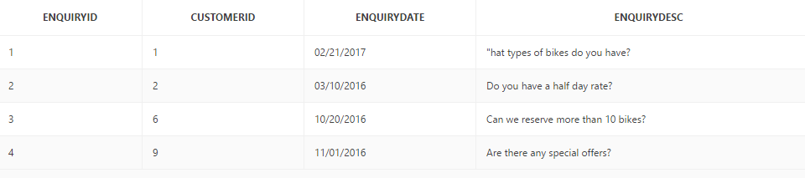

## 6. 2 Customer Record

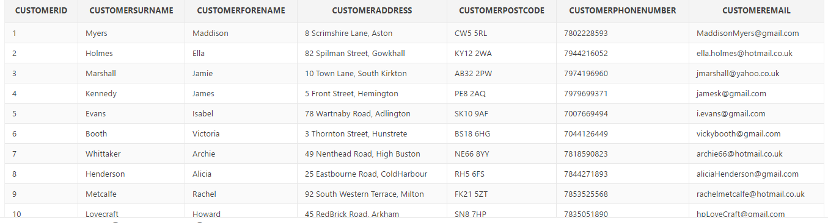

## 6. 3 Sold Bike Record

## 6. 4 Dealer Record

## 6. 5 Reservation Record

# 

## 6. 6 Bike Record

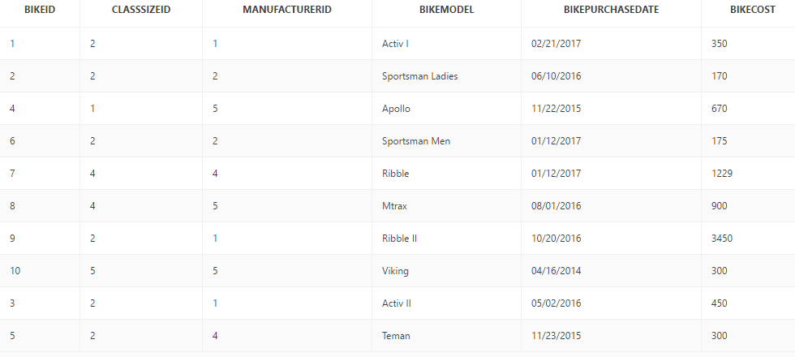

## 6. 7 Maintenance Record

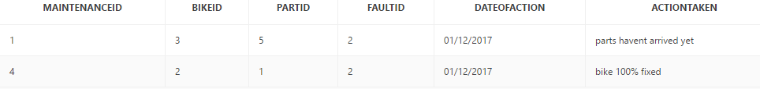

## 6. 8 Fault Report Record

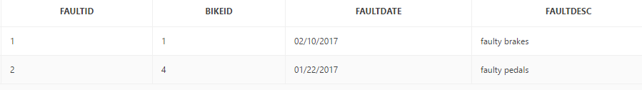

## 6.9 Manufacturer Record

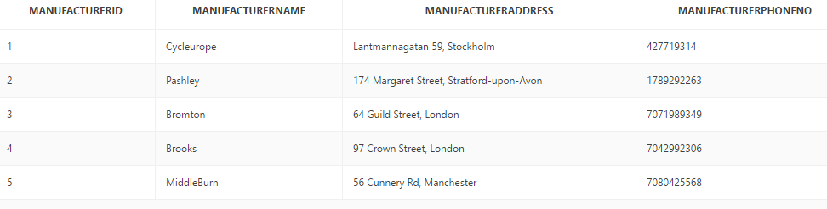

## 6.10 Supplied Parts Record

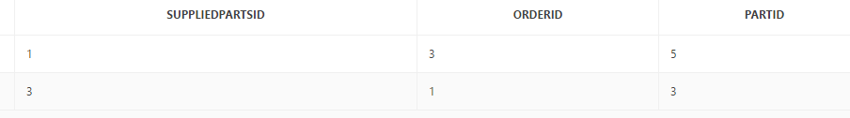

## 6.11 Class Size Record

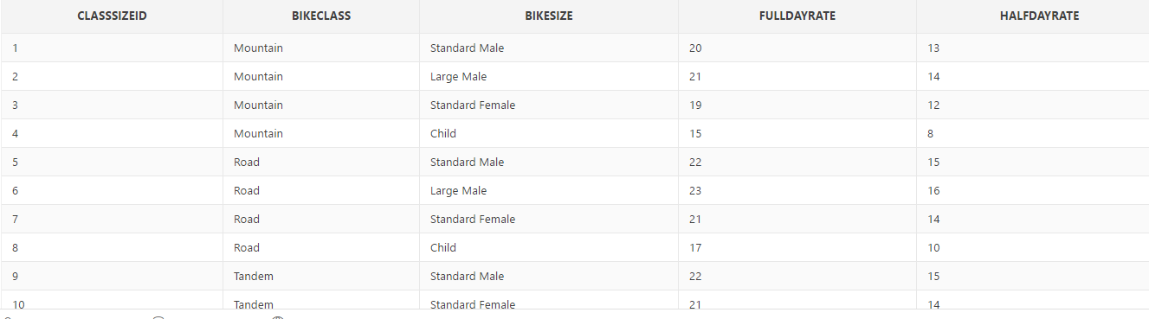

## 6.12 Bike Parts Record

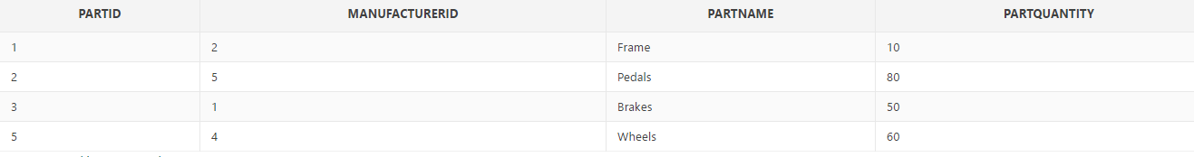

## 6.13 Parts Ordered

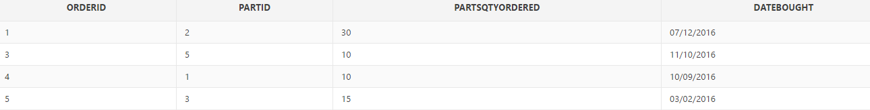

## 6.14 Rental Record

# 7.0 Appendix

# 

# 

# 

# 